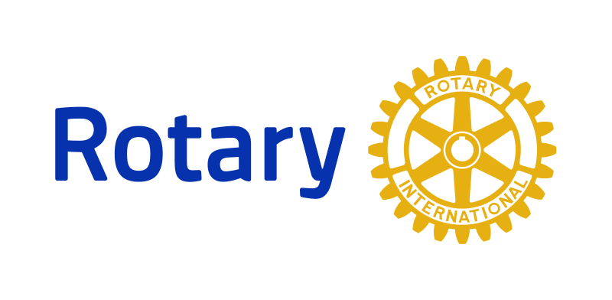**Two Way Orientation**

**Program & Outline**

The Two-Way Orientation Program for New Rotary Members is designed to provide a comprehensive introduction to Rotary and our club, as well as a way for new members to share their skills and interests with the club. The program includes both a structured orientation session and opportunities for new members to connect with existing members and contribute to club initiatives.

The Two-Way Orientation Program for New Rotary Members is an important component of our club's efforts to engage and retain members. By providing a comprehensive introduction to Rotary and our club's initiatives and values, we can help new members feel connected and motivated to contribute to our mission of making a positive impact in our community and beyond. We encourage all new members to participate in this valuable program and look forward to seeing the positive impact it will have on our club.

**Program Components:**

1. Structured Orientation Session: New members will attend a structured orientation session, where they will learn about the history of Rotary, our club's mission and values, and the structure and governance of our club. They will also learn about our club's committees, service initiatives, and social events.

2. Mentorship Pairing: New members will be paired with an experienced Rotarian who will serve as their mentor. Mentors will be selected based on their experience, knowledge, and commitment to Rotary's values and initiatives. Mentors will help new members navigate the club's activities and initiatives, as well as introduce them to other members.

3. Skills and Interests Assessment: New members will complete a skills and interests assessment, which will help match them with appropriate committees and service projects. This will also help the club identify new areas of expertise and interest that can be leveraged for future initiatives.

4. Club Meeting Attendance: New members will attend club meetings and events, where they will have the opportunity to connect with existing members and learn about ongoing initiatives. They will also have the opportunity to share their own skills and interests with the club.

5. Service Projects and Events: New members will be encouraged to participate in club service projects and events, and to contribute their own skills and interests to these initiatives. Mentors will help new members navigate these opportunities and find ways to make a meaningful contribution.

**Program Duration:**

- The orientation program will be ongoing, with new members joining on a rolling basis.

- Mentors will be expected to meet with their mentees regularly and provide guidance and support as needed.

**Program Benefits:**

- Provides a comprehensive introduction to Rotary and our club's initiatives and values.

- Helps new members feel engaged and connected to the club.

- Provides a way for new members to share their skills and interests with the club.

- Encourages mentorship and leadership development within the club.

- Helps the club identify new areas of expertise and interest that can be leveraged for future initiatives.